**BANGALORE INSTITUTE OF TECHNOLOGY**

**K R ROAD, V V PURA, BENGALURU-04**

**DEPARTMENT OF COMPUTER SCIENCE & ENGINEERING**

**Question Bank : Module 1& 2**

COURSE (CODE): **Database Management System (19CS53)**

1. **List the advantages of DBMS?**
2. **List the database Applications?**
3. **List the disadvantages of file processing system?**
4. **advantages of database approach over the file processing approach**
5. **List and explain the characteristics of DBMS.**
6. **Define instances and schemas of database?**
7. **Define (i) Entity (ii) Attribute**
8. **Discuss about Data Definition language?**
9. **Discuss about Data Manipulation language?**
10. **Discuss how can you change the data in the table?**
11. **Explain the different constraints on SQL with an example**
12. **Discuss How can you alter and destroy tables?**
13. **Explain data model and list the types of data model used?**
14. **Define the terms i) Entity type ii) Entity set**
15. **Define weak and strong entity sets?**
16. **Explain about stored and derived attributes?**
17. **Describe the This architecture contains three layers or levels of the database management system:**
18. **Define relational database query?**
19. **State about SELECT operation in Relational algebra?**
20. **Define Aggregate Functions?**
21. **Discuss the use of rename operation?**
22. **Illustrate division operation?**
23. **Discuss the basic form of SQL query?**
24. **Define Null Values.**

**Examples for ER diagram**

**UNIVERSITY DATABASE**



**ONLINE RETAIL APPLICATION DATABASE**



**MOVIE DATABASE**

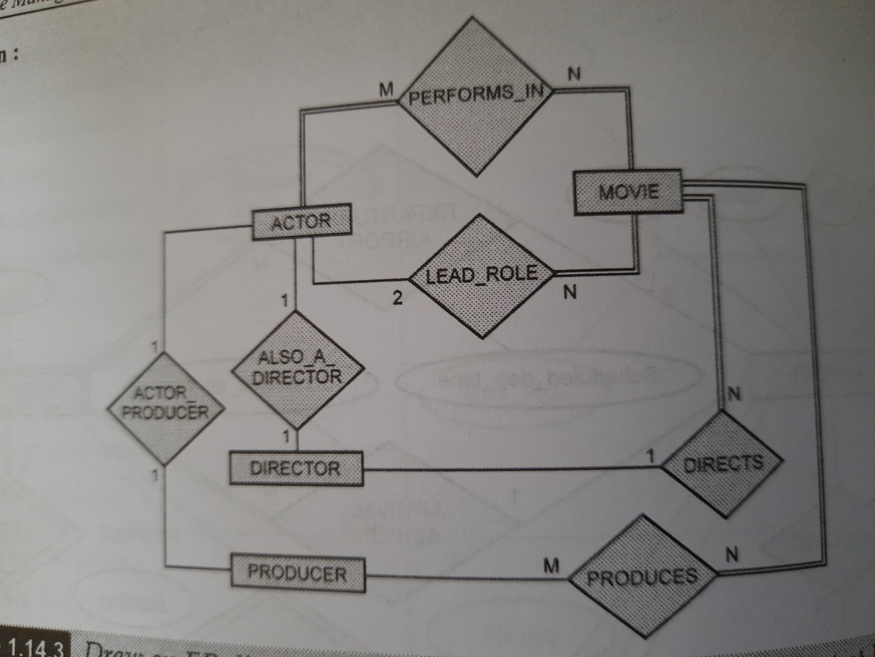

**BAK DATABASE**

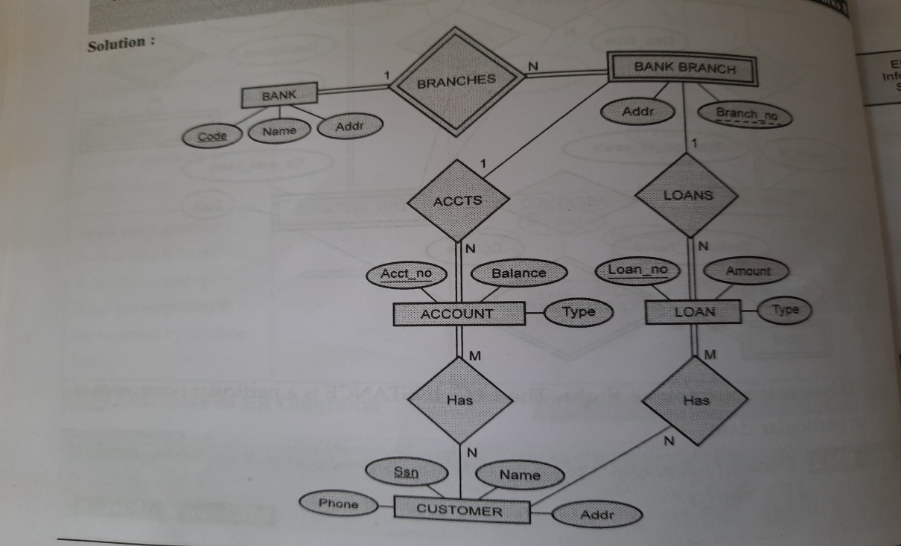

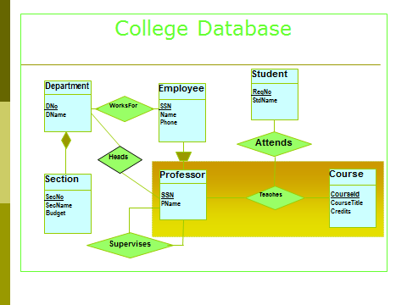

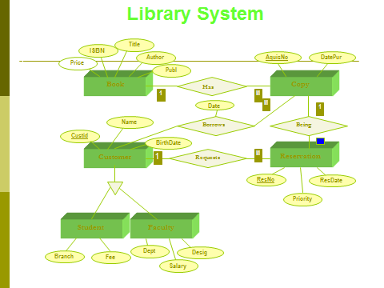

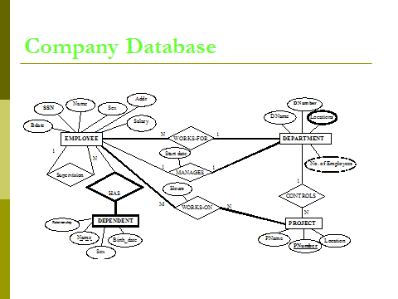

**ER diagram for AGGREGATION concept**

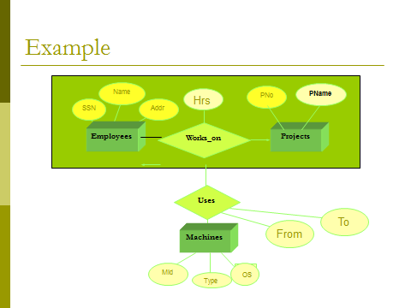

**]**

**ER diagram- Genaralization**

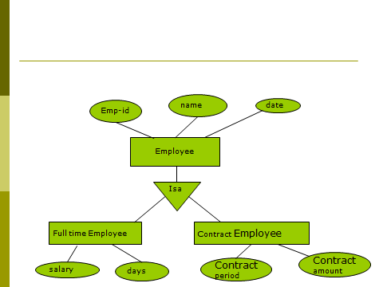

**SQL Queries**

1.LIST THE name and salary of the emps., whose salary is >10000

2.LIST the emp-no and name of the managers

3.LIST emp name and salary whose salary is between 10000 and 20000

4. List the details of the employees who have joined before end of SEPT.

5. LIST THE NAMES OF EMPS, WHO ARE NOT MANAGERS

6.List the employees belonging to the dept. 20

7. List the names of analyst and clerk

1. SELECT ename , sal from EMP WHERE sal>10000;
2. select empno,ename from EMP where job=’mgr’;
3. select ename , sal from EMP where sal between 10000 and 20000;

SELECT ENAME , SAL FROM EMP WHERE SAL > = 10000 and

SAL < = 20000;

4. Select * from emp where hiredate <= ’30-SEP-20’;

5. SELECT ENAME FROM EMP WHERE JOB <> ‘MGR’;

6.select * from Emp where dept=20;

7. SELECT ename FROM EMP WHERE job =’analyst’ or job =’clerk’;

**Consider the following schema for a Library Database:**

BOOK(Book_id, Title, Publisher_Name, Pub_Year)

BOOK_AUTHORS(Book_id, Author_Name)

PUBLISHER(Name, Address, Phone)

BOOK_COPIES(Book_id, Branch_id, No_of_Copies)

BOOK_LENDING(Book_id, Branch_id, Card_No, Date_Out, Due_Date)

LIBRARY_BRANCH(Branch_id, Branch_Name, Address)

1. Create table BOOK and PUBLISHER by specifying appropriate Primary key and foreign keys if any.
2. Add column no.of copies to BOOK
3. Insert values to BOOK database
4. CREATE TABLE PUBLISHER

(NAME VARCHAR2 (20),

PHONE INTEGER,

ADDRESS VARCHAR2 (20),

CONSTRAINT PKP PRIMARY KEY(NAME));

CREATE TABLE BOOK

(BOOK_ID VARCHAR(8),

TITLE VARCHAR2 (20),

PUBLISHER_NAME VARCHAR(20),

PUB_YEAR INTEGER,

CONSTRAINT PKB PRIMARY KEY(BOOK_ID),

CONSTRAINT FKB FOREIGN KEY(PUBLISHER_NAME) REFERENCES PUBLISHER(NAME));

1. ALTER TABLE BOOK ADD (No_of_Copies VARCHAR2(10));
2. INSERT INTO BOOK VALUES ('1','DBMS', 'MCGRAW-HILL',2017);

INSERT INTO BOOK VALUES ('2','ADBMS', 'MCGRAW-HILL',2016);

INSERT INTO BOOK VALUES ('3','CN', 'PEARSON',2016);

INSERT INTO BOOK VALUES ('4','CG', 'GRUPO PLANETA',2015);

INSERT INTO BOOK VALUES ('5','OS', 'PEARSON',2016);